
TECHNICAL PROPOSAL FOR IMPLEMENTING ONERP BUSINESS SOLUTION TO
KARMO GROUP

OnAir (Int’l) Ltd.
Research & Development Center
Sheikh Hasina Software Technology Part
Level 3, Jessore-7400, Bangladesh
Corporate Office
House 115, Road 04
Block B, Banani, Dhaka-1213
January 23, 2018
Table of Contents
Objectives Of The Project 12
Current Problems 13
Expected Project Benefits 14
A. Regulatory Framework and Financial Management 14
B. Productivity Improvements 14
C. IT Improvements 15
D. Staff Development 15
Solution Approach 17
Business Process Reengineering (BPR) 17
BPR Methodology of ONAIR™ 18
Change Management (CM) 19
Business Process Automation and Implementation of ONAIR™ 20
ONAIR™ Business SolutionTM 20
ONAIR™ Business Solutions™ Enterprise Architecture 21
Modules and Key Features of ONAIR™ Business Solutions™ for Mast Printing & Paper converting 26
Purchase & logistic Module 27
Transaction feature list (Import purchase)…………………………………………………………………………………………………………27
Settings (Import purchase) 27
Reports (Import purchase) 27
Transaction feature list (Local purchase)…………………………………………………………………………………………………………….27
Settings (Local Purchase) 27
Reports (Local purchase) 27
Managing Import with ONERP 27
Purchase Requisition 28
Purchase Quotation 29
Purchase Comparative Statement 27
Purchase Order 29
Purchase Pro-forma Invoice 30
Import LC opening 30
Purchase Commercial Invoice 31
Shipment Tracking & Monitoring 31
Managing Local Purchase with ONERP 33
Purchase Requisition 33
Purchase Quotation 33
Purchase Comparative Statement 33
Purchase Order 34
Purchase Invoice 34
Debit Note 34
Production Module 37
Transaction feature list 38
Settings 38
Reports 38
Production process flow diagram 38
Formulation/BOM 39
Production Receive, Consumption & Wastage Receive 39
Inventory Module 41
Transaction feature list 41
Settings 42
Reports 42
Inventory module process flow diagram 42
Item/Material Requisition 42
Purchase Receive 43
Internal Transfer Receive 43
Item Receive Against Sales Return 43
Item Delivery against Sales 43
Internal Transfer Delivery 44
Item Delivery against Purchase Return 44
Stock View 44
Damaged Goods Stock View 44
Sales & Distribution Module 46
Transaction feature list 46
Settings 47
Reports 47
Sales & Distribution module process flow diagram 47
Sales Order 48
Sales Invoice 48
Credit Note 48
Financial Accounting Module 50
Transaction feature list 51
Settings 51
Reports 51
Financial accounting module process flow diagram 51
Chart of accounts 51
Cheque issue 51
Cheque Receive 51
Journal 51
Cash payment 51
Cash receive 51
Bank Payment 51
Bank receive 51
Contra voucher 51
Bank reconciliation journal 51
HR & Payroll Module 54
HR & Payroll module process flow diagram 55
Human Resource Management Sub-Module 55
Recruitment 55
Employee database 55
Employee Life cycle 55
Attendance Management 56
Shift Management 55
HR Calendar 55
Overtime Management 55
Leave management 55
Performance appraisal 55
Training management 55
Payroll management 55
Reports 55
Settings, Configurations & User privilege feature list……………………………………………………………………………………………..58
Mobile Apps……………………………………………………………………………………………………………………………………………….………..59
Sales apps 59
Sales apps feature list 59
Catalog 59
Lookbook 59
Placing orders 59
GPS Location 59
Integration 59
On & off line mode 59
Sales Target & achievement apps 59
Non-Functional Requirements………………………………………………………………………………………………………………………….69
Performance Requirement 69
Security requirement 69
Software quality attributes 69
Training………………………………………………………………………………………………………………………………………………….…………….70
Post Implementation Services.………………………………………………………………………………………………………….…………….70
Support and Maintenance Services……………………………………………………………….…………………………..…….…………….70
Service Management………………………………………………………………………………………………………………………….…………….70
Service Level.……………………………………………………………………………………………………………………………………….…………….70
Response Time…………………………………………………………………………………………………………………………………….…………….70
Service Contract………………………………………………………………………………………………………………………………….…………….70
Deliverables..……………………………………………………………………………………………………………………………………….…………….70
The suggestive network Bandwidth………………………………………………………………………………………………….…………….70
Implementation Phases…………………………………………………………………………………………………………………….…………….70
Business Solutions Implementation Timelines.……………………………………………………………………………….…………….70
State-Of –The- Art Technology………………………………………………………………………………………………………….…………….70
Client/Server Technology………………………………………………………………………………………………………………….…………….70
Distributed Database System…..……………………………………………………………………………………………………….…………….70
Security……………………………………………………………………………………………………………………….……………………….…………….70

ONAIR™ BUSINESS SOLUTION

Objectives of the Project,

Current problem analysis &

Expected project benefits

Objectives Of The Project
There should be an objective behind doing anything in this world and ONERPTM implementation is not an exception. Business owners try to implement ERP system keeping some core objectives in mind. Go along with this piece of writing to know the core objectives of implementing ERP software.
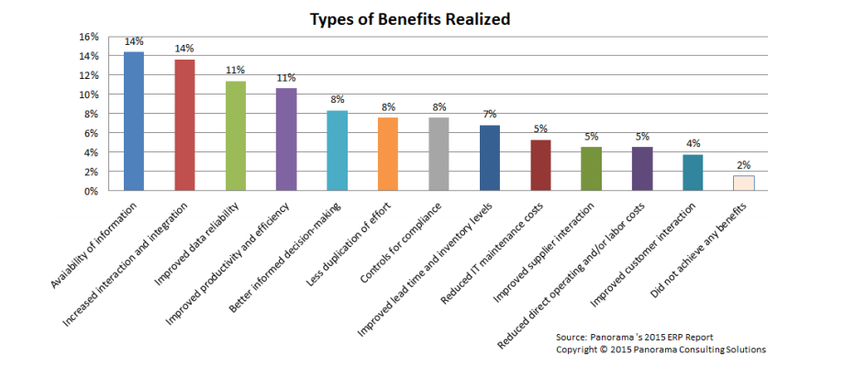
Our objective is to ensure customer driven enhancements to product lines. Our application ensures reduced down time, shorter upgrade cycles, and proven upgrade paths and methodologies more efficiently. Our Applications Unlimited program and lifetime support policy provide customers with a choice of what platforms and releases to be on and when to upgrade based on your company's business needs, rather than forcing you to upgrade. The Key objectives of the project are as below-

Current Problems
The greatest justifications for a robust ERP system are the shortcomings of existing administrative systems, required by KARMO GROUP to address these deficiencies:
- The current system does not provide a fail-proof financial accounting or supply chain process since its inception.
- The HR & payroll systems entail significant redundancies and could be consolidated to reduce the complexity of the reporting function.
- Intensive manual effort represents a significant cost to the company and dramatically reduces the efficiency and effectiveness of its business processes.
- No instant visibility into supply chain and other processes i.e. incomplete, often inaccurate picture of overall company performance.
- The company spends valuable time pulling together fragments from different spreadsheets, accounting sources, and sales orders to discover the company’s financial position.
- Lack of real-time data is a risk for company future.
- Inefficient and complicated processes across different departments.
- Unable to attain accurate answers to big questions, preventing from making better business decisions.

Expected Project Benefits
Reduced manual & paper work throughout the organization by the use of automated workflow and approval processes.
Quantification of benefits from the ERP system implementation is challenging. However, the consistent message that our business development team received is that there should be a very high focus on benefits tracking (from specific system functionality deployed) for each business area to ensure that the implementation is on track and is meeting business objectives.
The principal benefits of implementing an ERP system for the Organization may be summarized as follows.

A. Regulatory Framework and Financial Management
- The establishment of re-engineered and automated processes which are essential for the effective implementation of the new Financial Rules and Regulations and the approved new human resource strategy;
- The establishment of a basis for comprehensive and coherent internal control and accountability framework based on user roles, automated approval procedures and workflow;
- Enhanced functionality and system upgrade within Finance and Budget areas; and
- Establishment of an integrated and harmonized management reporting system that will provide high quality, reliable and consistent management information.

B. Productivity Improvements
- Realization of efficiency gains in all sectors within the scope of the project through simplification, streamlining and automation, in particular in those areas which are poorly supported by IT systems today;
- Reduced manual and paper work throughout the Organization through automated workflow and approval processes;
- Provide more reliable delivery dates & higher service to the customer;
- Change effort from managing activities to focusing on results;
- The provision of a standard tool set which will disseminate up-to-date financial information to Managers for the purpose of budget tracking; thus eliminating the need for parallel, manual or semi manual records to be maintained within each process;
- Better utilize/re-utilize raw materials & HR.

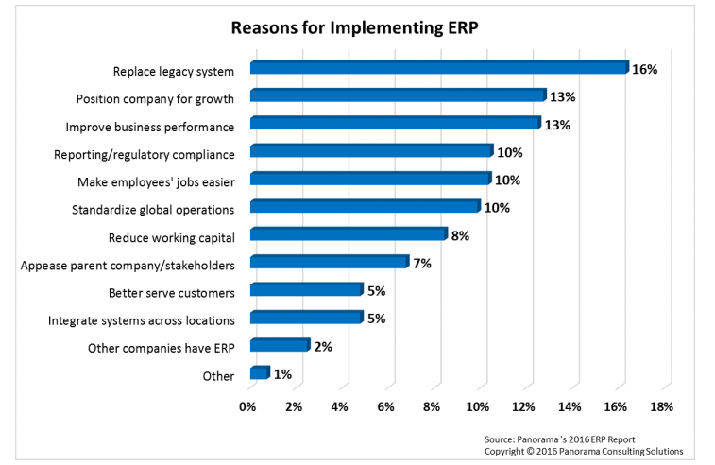

C. IT Improvements
- The retirement of a patchwork of legacy and departmental systems that are complex and expensive to maintain, and the establishment of a standard, unified IT platform for the key administrative and resource management applications; and
- Dedicated support of the system and a disaster recovery capability.

D. Staff Development
- ERP system implementations serve as an excellent platform or vehicle for training and professionalization of staff, (as users adapt to best practice based processes), higher data discipline and more value added analytical tasks facilitated by the improved availability of data. This has been the experience of other agencies who have undertaken such implementations.
Core processes’ transparency

Proposed robust enterprise solution:

ONAIR™ BUSINESS SOLUTION

Solution Approach
Many software companies offer customized software or software package as a product. But for the lack of expertise and experiences in the diversified business processes, business reengineering process (BPR) and change management (CM), most software companies are unable to provide complete solution. As a result, most ERP implementations fail. With its expert leaders of BPR, change management and technology, ONAIR™ offers the following services included as part of the comprehensive Business Solutions™ that are required for any successful implementation of ERP software:
- Facilitate business process reengineering (BPR).
- Facilitate change management (CM).
- Provide full-life cycle software development, configuration and customization services for the reengineered business process automation.
- Provide training for the new business processes and software.
- Provide post implementation services.

Each of the solutions and services mentioned above will be described in further details in the next few sections, and altogether will be considered as the Business Solutions™ package offered by the ONAIR™. ONAIR™ will provide the services as needed for the successful implementation of the ONAIR™.

Business Process Reengineering (BPR)
While implementing an automated system from manual processes, there is a great opportunity to re-evaluate the existing manual processes for converting them to more efficient and robust ways of doing business since manual processes may have limitations that are easy to overcome via automated system. However, it is even more important and is a must that business process reengineering (BPR) is considered while implementing an enterprise system. If the existing systems are simply emulated in the automated system, it fails to provide any advantage, so the cost associated with the automation becomes worthless.

BPR Methodology of ONAIR™
ONAIR™ will facilitate the BPR using the following life-cycle of the business reengineering processes:

Figure: Business Process Reengineering (BPR) Life Cycle

As indicated in the above process-flow of the business reengineering process (BPR) cycle, ONAIR™ will reengineer the KARMO GROUP business processes in these four stages:
a. Identify KARMO GROUP Current Business Processes
In this stage, with the assistance and cooperation from KARMO GROUP top management, ONAIR™ will discuss with all the functional heads of KARMO GROUP to identify all the existing business processes in operation.
b. Analyze KARMO GROUP “As-Is” Processes
Once the KARMO GROUP current business processes are identified, the ONAIR™ Business Solutions™ Architecture Team will analyze the current “As-Is” business processes to determine the necessary update or reengineering areas and processes.
c. Design the KARMO GROUP “To-Be” Processes
From the analysis outputs of the “As-Is” business processes, the ONAIR™ Business Solutions™ Architecture Team will design the “To-Be” business processes to fulfill the criteria of the BPR initiative.
d. Test and Implement KARMO GROUP “To-Be” Processes
ONAIR™ will review the designed “To-Be” business processes with the KARMO GROUP stakeholders, and plan on incorporating the “To-Be” design to be automated. Based on the review feedback and suggestions, ONAIR™ will further update the designed “To-Be” processes. The implementation of the software automation to test and implement the “To-Be” business processes, will follow the Change Management (CM) Plan and Implementation of the Web Based Integrated ONAIR™.

Change Management (CM)
For any successful business process reengineering (BPR) and implementation of any enterprise software solutions to align with the newly designed business processes, changes must be planned and controlled appropriately. For this reason, ONAIR™ Business Solutions™ offered for the KARMO GROUP will include a comprehensive business process change management (CM) plan. The change management plan will help managing the following change processes so that the desired changes are successfully implemented:
a. Change Management Communication Plan
To obtain buy-in and support from all stakeholders, counter and handle resistance from employees, align everyone to the strategic directions of the organization, and implement all required changes successfully, all changes and tasks associated with the changes must be communicated properly to all appropriate individuals, teams and departments on time. To carry out all communications correctly and on time, ONAIR™ will develop a change management communication plan for the KARMO GROUP as part of the Business Solutions™ package. The change management communication plan will identify “who,” “where,” “how” and “when” to communicate associated with a desired change.
b. Reasons of Changes
As part of the BPR process when the ONAIR™ Team analyzes the “As-Is” business processes and determines the areas of business processes to be modified, for each change will be documented, and they will be communicated to the appropriate stakeholders of KARMO group’s different business functions using the change management communication plan. The goals of this exercise are to get the buy-in of the stakeholders for the change and prepare the stakeholders for the change implementation when it happens.
c. Identifying Changes to Implement
Once the “To-Be” business processes are designed, not all processes may be feasible to implement at the same time. Or some changes may be “nice to have” and can be deferred for future implementations. And the changes to be implemented will be phased out for different iterations. The Implementation Plan section will provide the phase out implementation plan for the changes. As part of the change management plan, each change will be identified and selected for the implementation.

d. Impacts of the Changes
Along with reasons of changes, ONAIR™ will identify all impacts to the other business processes and resources of the KARMO GROUP, associated with each change, as part of the change management process when, as part of the BPR process, the ONAIR™ Team analyzes the “As-Is” business processes and determines the areas of business processes to be modified. If training is required for the resources to be familiar with the new processes, ONAIR™ will provide the necessary training associated with the ONAIR™ system as described in the Training Section.

Business Process Automation and Implementation of ONAIR™
Once the “To-Be” business processes are designed following the BPR process, ONAIR™ will install, configure and implement the ONAIR™ systems for the automation of the KARMO group’s “To-Be” business processes.

ONAIR™ Business SolutionTM
ONAIR™ is a robust web based integrated ERP system for all business sectors. Prior to the design and development of the ONAIR™ and Business Solutions™ packages, ONAIR™ addresses the primary reasons, for those ERP projects fail majority of the time. Reasons of the high rate of ERP projects failure are myriad. However, the endless reasons are due to the flaws or management of these three broad areas:

For any successful ERP software development and implementation, the above factors need to be addressed, and without identifying/incorporating solutions to each of these, the risk of failure will remain. ONAIR™ has addresses each of these issues from the very beginning of the development of the ONAIR™ Business Solutions™. And ONAIR™ will address these issues while implementing the ONAIR™ Business Solutions™ to the MAST & Aegis. While the organizational dynamics and human elements issues are handled and addressed in BPR and Change Management solutions, ONAIR™ ’s architectural design and capabilities and the Software Development Methodology that ONAIR™ leverages. The next sub-sections will describe the ONAIR™ Business Solutions™ and its capabilities. From the system’s vast capability, ONAIR™ will configure and customize as necessary to align with the “To-Be” business processes once identified and designed.

ONAIR™ Business Solutions™ Enterprise Architecture

As stated earlier, design flaws within the ERP software make it impossible to adapt complex business processes when changes are mandatory. As a result, the ERP project may fail before its completion or the software becomes useless after a while. This is the main reason as to why many companies are forced to scrap implemented systems and are required to develop a new system from scratch. To address this and avoid failure or scrap of systems, any ERP architecture needs to be very carefully designed to allow flexibility to keep the future modifications in mind. It also needs to be reliable and scalable. The architectural design, therefore, is the foundation of the ERP software. And sufficient time allocation is necessary to understand the overall business processes and the associated business data before the design and development of the architectural or foundation framework for the ERP solution. This fundamental understanding leads more advanced ERP solution to design and develop an enterprise architecture for the ERP solution.
The primary reason for developing enterprise architecture is to support the business by providing the fundamental technology and process structure for an IT strategy. This in turn makes IT a responsive asset for a successful modern business strategy.
Today's CEOs know that the effective management and exploitation of information through IT is the key to business success, and the indispensable means to achieving competitive advantage. Enterprise architecture addresses this need, by providing a strategic context for the evolution of the IT system in response to the constantly changing needs of the business environment.
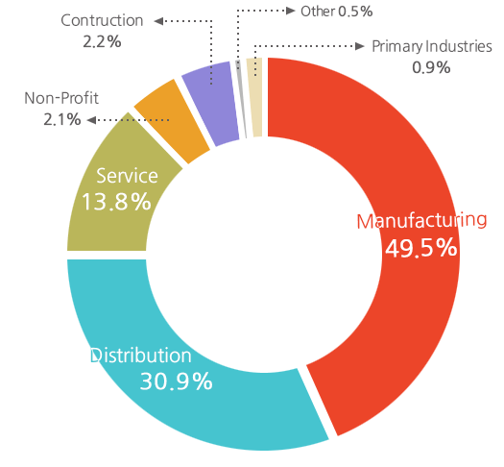
Furthermore, a good enterprise architecture enables you to achieve the right balance between IT efficiency and business innovation. It allows individual business units to innovate safely in their pursuit of competitive advantage. At the same time, it assures the needs of the organization for an integrated IT strategy, permitting the closest possible synergy across the extended enterprise. Unfortunately, many software developers simply either do not understand the need of the enterprise architecture or they lack in expertise to develop one or they may intentionally avoid addressing it as it requires significant investment. Thus, without an effective and structured enterprise architecture solution, it may be faster to develop the loosely coupled or even integrated ERP modules, but the solution may not be a lasting one.
Keeping the above views in mind, over the years, ONAIR™ has developed an enterprise architectural framework, which is the foundation of the ONAIR™ . It is a general ERP suitable for any industry. The architecture is seamlessly superior to other existing enterprise architectures. To some extent the ONAIR™ Enterprise Architecture has followed TOGAF framework. However, in general, it is developed by following global general business needs and enterprise practices. The hierarchy of the ONAIR™ Enterprise Architecture is as follows:

The ONAIR™ Enterprise Architecture is a multi-tier architecture, having different layers classified as:

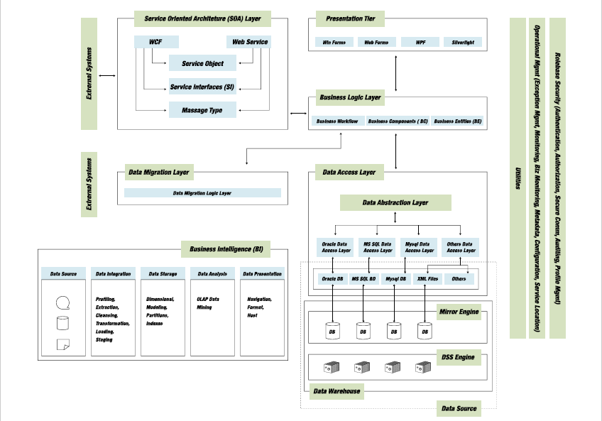

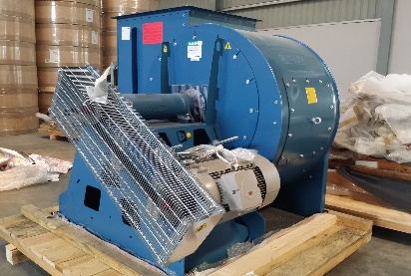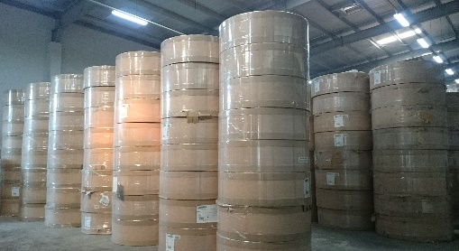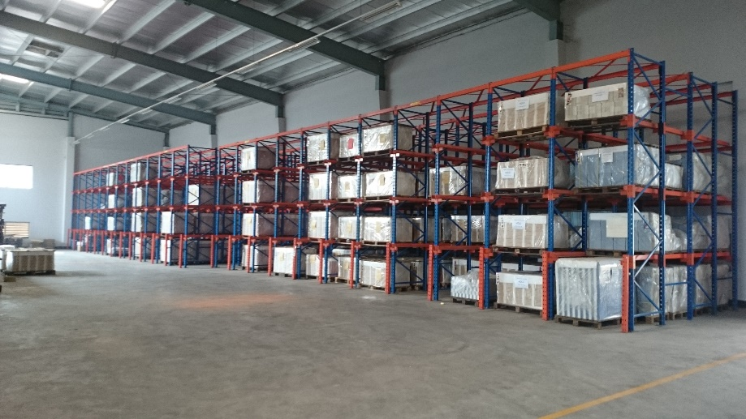

ONERP business solution for

KARMO GROUP

Modules and Key Features of ONAIR™ Business Solutions™ for KARMO GROUP converting
- Settings, Configurations & User Privilege Module
- Purchase & Logistics Module
- Production Module
- Inventory Module
- Sales & Distribution Module
- Financial Accounting Module
- Human Resource & Payroll Management Module
- Mobile Apps

Purchase & Logistics Module
The procurement department is responsible for purchasing materials in the right quantities of the right quality at the right time. Companies which purchase material from different vendors in large and varying quantities require a good ERP purchase module.
ONERP Purchase & Logistics module automates the processes of identifying potential suppliers, Supplier Quote Evaluation, awarding purchase order to the supplier and billing processes.

Transaction feature list (Import purchase)
- Purchase Requisition
- Purchase Requisition Approval
- Purchase Quotation
- Purchase Quotation Approval
- Comparative Statement
- PI Collection
- LC Opening/TT/Insurance/Bank Commission/Custom Duties/CNF Agent Commission/Track Fare/ Loading & Unloading Cost
- Shipment Tracking & Monitoring

Settings (Import purchase)
- Foreign supplier Setup
- supplier Address Setup
- Supplier Contract Setup
- Supplier Bank Account Setup
- Terms & Conditions Setup
- Financial Term Setup
- Credit Limit Setup

Reports (Import purchase)
- Purchase Requisition: Purchase Requisition No, Item, Branch wise, Date Range Wise and Progress Status.
- Purchase Quotation: Purchase Quotation No, Item, Supplier, Date, Progress Status.
- CS Reports: CS No, Date wise, Branch
- Purchase Order: Order No, Item, Supplier, Date Range Wise, Project, Status, Delivery Progress Status.
- Pro-Forma Invoice: Purchase Order No, Supplier, Item, Date Range Wise.
- LC: Supplier, Purchase Order, Item, Record Date, LC Date, LC Type, LC. No., LC Value, Cost Centre, Bank, Bank Account No, PO, PI, Status.
- Commercial Invoice: Supplier, Purchase Order, Date, Cost Centre, Bank, Bank Account No, PO, PI, Status, Paid, Balance.

Transaction feature list (Local purchase)
- Purchase Requisition
- Purchase Requisition Approval
- Purchase Quotation
- Comparative Statement
- Purchase Quotation Approval
- Purchase Order
- PI Collection
- Purchase Invoice
- Purchase Debit Note

Settings (Local Purchase)
- Supplier Setup
- Supplier Address Setup
- Supplier Contract Setup
- Supplier Bank Account Setup
- Terms & Conditions Setup
- Financial Term Setup
- Credit Limit Setup

Reports (Local purchase)
- Purchase Requisition: Purchase Requisition No, Item, Branch wise, Date Range Wise and Progress Status.
- Purchase Quotation: Purchase Quotation No, Item, Supplier, Date, Progress Status.
- CS Reports: CS No, Date wise, Branch
- Purchase Order: Order No, Item, Supplier, Date Range Wise, Project, Status, Delivery Progress Status.
- Purchase Invoice (Challan): Supplier, Purchase Order No, Item, Date Range Wise.
- Debit Notes: Item, Date, Supplier, Status.

Managing Import with onERP
KARMO imports a number of supplies including raw materials, spare parts and machineries frequently. Here is the strategy to mitigate the import related issues with ONERP:

Figure: Purchase TO BE Business Process: Import

Purchase Requisition
Purchase requisition can be made on the Internal Item Demand (Requisitions). Any requisition made, must be required to be passed through the approval process in order to refer them while any purchase is done following the Purchase requisition. Purchase requisition can be made with the reference of Item Requisition. It includes the information listed below.
- Reference which the requisition is made for
- Item detail with last purchase price
- Approval status

Purchase Quotation
Purchase quotation can be made with the reference of Purchase Requisition. The information will be there in the quotation are as below.
- Reference which the quotation is made for
- Item detail with Price
- Pack Info
- Taxes and Duties
- Financial terms and conditions
- Delivery schedule/plan
- Terms and Conditions
- Approval status

Purchase Comparative Statement
Purchase quotation comparative statement shows the price comparison of different supplier placed against a Purchase Requisition. CS can be approved multiple suppliers. Once the quotation is approved in the CS the respected Quotation status becomes approved and purchase order can be made based on the quotation.
After getting all the quotation submitted by suppliers authorized user can compare the received quotations from different suppliers for different items.

Purchase Pro-forma Invoice
Pro-Forma Invoices are documents that state commitment from the seller to sell goods to the buyer at the specified prices and terms. It is used to declare the value of the trade. Following the Purchase quotation, Purchase PI is delivered by the supplier.

The Pro-Forma Invoices can be made refereeing the Purchase Quotation. The information will be there in the PI are given below.
- Reference which the quotation is made for
- Item detail with Price
- Contact Person Info
- Warranty/ Claim
- Loading Address
- Discharge Address
- Payment term
- Shipment
- Document

Import LC opening
ONERP supports you to manage your LC information effectively and effortlessly. You can manage vendors’ documents, goods receive & payment related information with no trouble. It has an all-encompassing feature than you can add all expenses as cost with imported items. Aside, ONERP facilitates LC related bank payment simply.
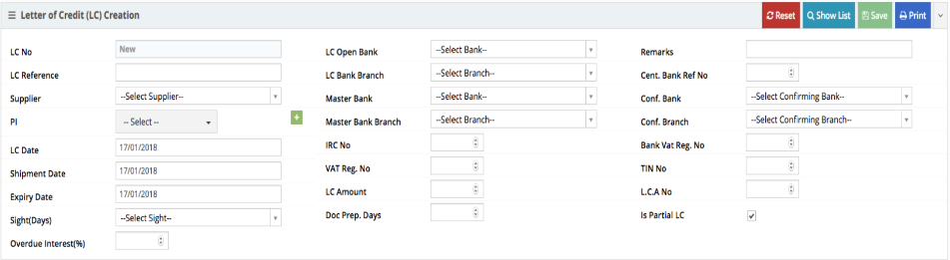
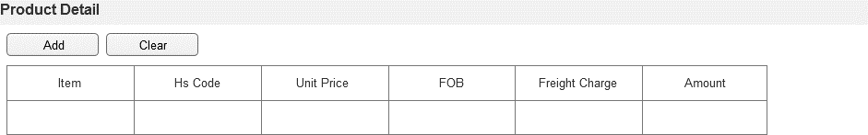
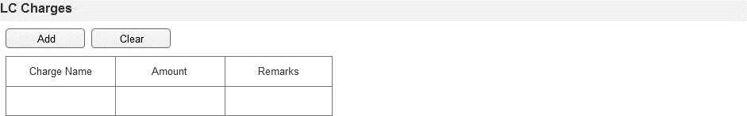

Purchase Commercial Invoice
Purchase Commercial invoice is the official invoice, which will contain the purchase order related information and Purchase Pro-Forma Invoice as in reference. Approved Commercial Invoice Integrates Accounting. Commercial Invoice Updates the Item Price given in the MRR referred during invoice entry. If MRR reference is not given, then the respected item’s purchase price may not show in the inventory. It contains all required standard information.

Shipment Tracking & Monitoring
Shipment monitoring allows procurement department to track the current situation of the importing supplies.
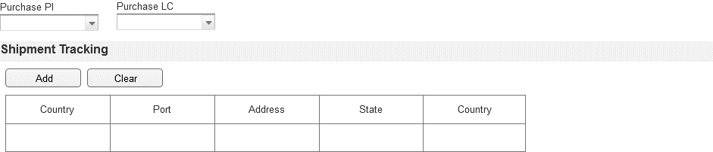
As an example KARMO executive wants to know in which stage the ordered board is in i.e. is it in current stock/in Chittagong port/in ship near to CTG/in supplier’s stock/waiting for production. He will select the supplier of that particular order no and search whether it is already delivered or partially delivered.

Managing Local Purchase with ONERP
Figure: Purchase TO BE Business Process: Local Purchase

Purchase Requisition
KARMO can place purchase requisition for its local purchase separately. And surely it will pass through the approval process.

Purchase Quotation
For local purchase KARMO can ask for purchase quotation from several suppliers. From local market there are several items that KARMO purchases. To have a good price and to ensure win-win situation quotation can be asked for all the required items.

Purchase Comparative Statement
Purchase quotation comparative statement shows the price comparison of different supplier placed against a RFQ/Purchase Requisition. CS can be approved multiple suppliers. Once the quotation is approved in the CS the respected Quotation status becomes approved and purchase order can be made based on the quotation.
After getting all the quotation submitted by suppliers authorized user can compare the received quotations from different suppliers for different items.

Purchase Order
Following the Purchase quotation, Purchase Order is awarded to the supplier(s). The information will be there in the Order are following general standard.

Purchase Invoice
This form ensures all types of invoice are received against every MRR and the cost of the item purchased are updated according to the Cost settings. The invoices it covers are Supplier Invoice, Transport Invoice, Agent’s Invoice, and Other Invoices.

Debit Note
Any item purchased can be required to have Debit note. ONERP supports Purchase Debit Note transaction and updates required accounting accordingly.

Production Module
Production module is unique sub-system of ONERP which provides the best fit manufacturing systems. Being tightly integrated to other processes makes the information support to production very efficient. On top of that you will find out how easy it is to handle and track batches and serial numbers. Well-organized manufacturing process, resulting elimination of bottleneck and waste, necessitates greater reliance upon flexible and user friendly production planning and control system. The ironic features of this module are as followings:

Transaction feature list
- Formulation/ Bill Of Material(BOM)
- Products Received, Consumed & Wastage Received

Settings
- Phase/ Process Setup
- Shift Setup

Reports
- Consumption: Item, Cost Centre, Date Range, Shift.
- Production: Item, Cost Centre, Date Range, Shift.
- Wastage: Item, Cost Centre, Date Range, Shift.

production process flow diagram

Figure: Production TO BE Business Process

Formulation/BOM
As you are operating production operation, the number of recipes you need to maintain accurately and consistently which can be frightening. ONERP Recipe management subsystem cuts the effort to accomplish your product formulations and setup specifications on automated production equipment and machines in manufacturing. Also, this electronic history records will empower your operational teams to improve productivity and quality.

Production Receive, Consumption & Wastage Receive
Production Receive allows finished goods, Wastage receive and the consumption of the received items are automatically inserted according to the Bill of Materials/Formulation referred in the Production Receive Record during the transaction.

Inventory Module
This is another core module of ONERP integrated with all required modules in maximum efficiency and accuracy. Integrated modules are Purchase Module, Sales Module, and Accounting Module.

Transaction feature list
- Item Requisition
- Purchase Receive MRR
- Internal Transfer MRR
- Sales Return MRR
- Internal Delivery
- Sales Delivery
- Purchase Return Delivery

Settings
- Delivery Type Setup
- Price Method Setup
- Item Entry
- Barcode/ QR Code Generation
- Item Re-Order Level Setup(Buffer Stock)

Reports
- Purchase Receive: Item, Supplier, Cost Centre, Date Range.
- Sales Return MRR: Item, Customer, Cost Centre, Date Range.
- Internal Transfer MRR: Item, Cost Centre, Date Range, From Branch
- Sales Delivery: Item, Customer, Cost Centre, Date Range.
- Internal Transfer Delivery: Item, Cost Centre, Date Range, To Branch
- Purchase Return Delivery: Item, Supplier, Cost Centre, Date Range.
- Stock: Item, Cost Centre, Item Category, Item Condition.

Inventory module process flow diagram

Figure: Inventory TO BE Business Process

Item/Material Requisition
Any item can be requested by any user having access to the system. Every single requisition may complaint with the approved plan. If requisition is based on any specific reference i.e. production order, then it may check and control the items those should be transacted. No false requisition will be allowed to proceed.
Item Requisition-different department: Re-Order Level/ Safety Stock Based Auto Generation.

Purchase Receive
Every MRR will be created referring the PI/PO and it will update the Inventory & Accounting.

Internal Transfer Receive
This MRR can be created referring the approved ‘Item Delivery against Inter Branch Requisition’. The Items can be received using barcode or IME number or serial number or QR code and the items will be automatically located to assigned shelf location. If needed user can re-locate the shelf for the item(s) received in a MRR.
This newly created MRR pass through the Approval flow, if this transaction page is set for it. Once the MRR is generated immediately the stock will be updated to respective shelf in the warehouse.
There will have a receive note printing option and user can get a print of it and keep it for future need if necessary.

Item Receive Against Sales Return
This MRR will be created referring the approved Sales Invoice or approved commercial invoice.

Item Delivery Against Sales
Every delivery is subject to the approved Sales Invoice/Commercial Invoice.

Internal Transfer Delivery
This delivery take place once any kind of internal item requisition is made and approved. Reference should be Item Requisition.

Item Delivery against Purchase Return
This delivery take place once any kind of purchased item is returned to supplier. Reference will be Purchase Invoice. The Items can be delivered using barcode or QR code and the items will be automatically located to assigned shelf location. If needed user can re-locate the shelf for the item(s) delivered. Once and item is selected the located of the shelf shall be shown automatically and will show the stock quantity for the specific warehouse & shelves.
There will have a delivery challan printing option and user can get a print of it and keep it for future if needed.

Stock View
This is the page where the stock of each item will be shown location basis. User will be allowed to filter the stock by 360-degree parameters i.e. Branch, Item Category, Item, Receive Quantity, Issue Quantity, Current Stock.
Empty shelves or the vacant shelves can be monitored from this dashboard. From this board user will be allowed to see the detail items stored into the respective shelves.

Damaged Goods Stock View
Damaged goods stock view page will show the wastage or damaged goods. User can filter damaged goods stock using 360-degree parameters i.e. Branch, Item Category, Item, Receive Quantity, Issue Quantity, Current Stock.

Sales & Distribution Management Module
ONERP Sales & Distribution Management module will let KARMO to organize and track the sales process in an efficient way. This module incorporates functionality for Sales Order Management, Sales Forecast, quickly creating a Quote or migrating them to Sales order, Sales Invoicing, Item Return, Cr Note, Bill Collection & Analysis and dispatch to boost up the revenue.

Transaction feature list
- Sales Order
- Sales Order Approval(Credit Limit, Product availability/Stock)
- Sales Invoice & Challan
- Sales Credit Note

Settings
- Customer Setup
- Customer Address Setup
- Customer Contact Detail Setup
- Customer Accounting Setup
- Customer Credit Limit Setup
- Discount Setup
- Offer Setup
- Tax Rate Setup
- Payment Method Setup
- Terms & Conditions Setup
- Pack Setup
- Warranty Type Setup
- Item Price Setup

Reports
- Sales Statement (Daily, Monthly): Item, Client, Cost Centre, Date Range Wise.
- Bill & Collection: Month, Date Range Wise, Client, Invoice, Item, Cost Centre.
- Sales Order: Sales Order No, Cost Center, Client, Date Range Wise.
- Sales Invoice: Invoice No Wise

Sales & Distribution module process flow diagram

Figure: Sales & Distribution TO BE Business Process

Sales Order
After getting the work order, KARMO authorized user can input the sales order in this page. User can add an item from the list. ONERP comes with more advanced features i.e. user can scan the barcode/QR code of the item. Product related information will fill automatically.
Also, user can upload and store the scanned copy of the work order.

Sales Invoice
Sales invoice is an important transaction process for the sales modules. This page lets you create invoices and print for faster payment.

Credit Note
Any item sold can be required to have Credit note. ONERP supports Purchase Credit Note transaction and updates required accounting accordingly.

Financial Accounting Module
Complete Financial Accounting System maintains all financial year wise transaction, and fully integrated with sales, purchase, payroll, inventory, and other relevant modules, helps in generating different types of vouchers such as, credit, internal transfer, journal, etc., Calculation of TDS Vat/ or other Taxes while making payment. Maintain the payment detail made to the external parties, Automatic generation of purchase payment Voucher for the purchase bill, Automatic Sales Vouches while making sales.

Transaction feature list
- Cheque Issue
- Cheque Receive
- Journal Voucher
- Cash Payment Voucher
- Cash Receive Voucher
- Bank Payment Voucher
- Bank Receive Voucher
- Contra Voucher
- Bank Reconciliation Voucher

Settings
- Chart Of Accounts Setup
- Bank Account Setup
- Balance Sheet Settings
- Income Statement Settings
- Cash Flow Statement Settings
- Cheque Status Setup
- Cheque Type Setup
- Cheque Book Generation

Reports
- General Ledger:[PARMS: COA Head, Cost Center, Project, Fiscal Year, From Date, To Date]
- Trial Balance:[PARMS: Cost Center, Project, Fiscal Year, From Date, To Date]
- Income Statement:[PARMS: Cost Center, Project, Fiscal Year, From Date, To Date]
- Cash Flow Statement:[PARMS: Cost Center, Project, Fiscal Year, From Date, To Date]
- Journal Transaction Detail:[PARMS: Cost Center, Project, Fiscal Year, From Date, To Date]
- Party Ledger:[PARMS: Party, COA Head, Cost Center, Project, Fiscal Year, From Date, To Date]
- Bank Reconciliation:[PARMS: Cheque Transaction Type, Cheque No, Cheque Status, Journal, Bank Account No, From Transaction Date, To Transaction Date]
- PDC List:[PARMS: Cheque Transaction Type, Cheque No, Cheque Status, Journal, Bank Account No, From Transaction Date, To Transaction Date]

financial accounting module process flow diagram

Figure: Financial Accounting TO BE Business Process

Chart of accounts
- Transactional head at any level
- Only Transactional head should be available to the transactional page
- If party mandatory is true then transactional page should validate the party is required.
- If default cash head is true then default cash head automatically available to the cash payment & cash receive transaction

cheque issue
The following preconditions are required for cheque issue
- Party setup should be in the system
- Bank Account setup should be in the system
- Cheque Status list should be in the system
- Generated cheque book should be in the system
Business logic:
- One cheque issue against multiple invoice
- After cheque issue that will impact to the financial statement
- Cheque print required

cheque Receive
The following preconditions are required for cheque Receive
- Party setup should be in the system
- Bank Account setup should be in the system
- Cheque Status list should be in the system
- Submitting bank should be in the system
Business logic:
- One cheque Receive against multiple invoice
- After cheque status is honored then impact to the financial statement

Journal
The following preconditions are required for journal voucher
- Currency rate setup should be in the system
- Chart of account setup should be in the system
- Cost center list should be in the system
Outcomes: Journal voucher print & only approved journal should be impact to the financial statement
Business logic
- Debit & Credit must be equal
- Any detail head can’t be empty

Cash payment
The following preconditions are required for cash payment voucher
- Chart of account setup should be in the system
- Cost center list should be in the system
Outcomes: Cash payment voucher print & only approved cash payment voucher should be impact to the financial statement
Business logic
- Debit & Credit must be equal
- Any detail head can’t be empty

Cash receive
The following preconditions are required for cash receive voucher
- Chart of account setup should be in the system
- Cost center list should be in the system
Outcomes: Cash receive voucher print & only approved cash receive voucher should be impact to the financial statement
Business logic
- Debit & Credit must be equal
- Any detail head can’t be empty

Bank

Bank Payment
The following preconditions are required for bank payment voucher
- Chart of account setup should be in the system
- Cost center list should be in the system
- Party Setup should be in the system
- Bank Account setup should be in the system
- Cheque book setup should be in the system
Outcomes: Bank payment voucher print & only approved bank payment voucher should be impact to the financial statement
Business logic
- Debit & Credit must be equal
- Any detail COA head can’t be empty
- Party should be mandatory for payable head
- Bank payment against multiple invoice

Bank receive
The following preconditions are required for bank receive voucher
- Chart of account setup should be in the system
- Chart of account setup should be in the system
- Cost center list should be in the system
- Party Setup should be in the system
- Bank Account setup should be in the system
Outcomes: Bank receive voucher print & only approved bank receive voucher should be impact to the financial statement
Business logic
- Debit & Credit must be equal
- Any detail COA head can’t be empty
- Party should be mandatory for payable head
- Bank receive against multiple invoice

Contra voucher
The following preconditions are required for contra voucher
- Chart of account setup should be in the system
- Cost center list should be in the system
Outcomes: contra voucher print & only approved bank contra voucher should be impact to the financial statement
Business logic
- Debit & Credit must be equal
- Any detail head can’t be empty

Bank reconciliation journal
The following preconditions are required for contra voucher
- Chart of account setup should be in the system
- Cost center list should be in the system
Outcomes: Bank reconciliation journal print & only approved bank reconciliation journal should be impact to the financial statement
Business logic
- Debit & Credit must be equal
- Any detail head can’t be empty

HR & Payroll Module
Our HRIS Solution is named as ONHRIS. It’s an application to facilitate the complex task of managing human resources, Attendance & payroll. It is a tremendous tool which enables user to manage personnel info, attendance, training, payroll, production data capture, provident fund, income tax, disciplinary action, performance appraisal, manpower management, e‐recruitment etc. Any other add on modules can be added as per client requirement.
System is a fully integrated, modular, flexible and customizable web based solution. It provides a manager or to the employees instant access to relevant information and HR activities. It can control the user access with the specific permission of insert, update, delete.

The following is brief description modules, including the basic system architecture. The core modules are included in every installation and the rest of the system depends on your specific needs and modules requested.

HR & Payroll module process flow diagram

Figure: HR & Payroll Management TO BE Business Process

A set of ironic features of this module are as follows:

Human Resource Management Sub-Module

Recruitment
- Man power Budgeting
- Appointment Letter
- Joining Letter
- Confirmation Letter

Employee database
The core module maintains all relevant employee related information, including different types of personal information, employee picture and signature included. Expatriate information, detailed qualifications and work experience, job related information, utility information etc. Information captured in this module is utilized by other modules, thus eliminate data redundancy.
- Personal Info
- Family info
- Official Info
- Job Responsibility
- Skill Info
- Educational Info
- Employment History

Employee Life cycle
Facilitates easy and comprehensive management of changes in employee movements within the organization, includes user friendly application and approval of transfer, promotions, job confirmation, increment, separation etc.
- Transfer
- Promotion
- Job confirmation
- Increment
- Separation
- Final Settlement etc.

Attendance Management
It has flexibility for managing shift and roster with the ability to monitor employees attendance. ONHRIS supports all phases of roster management from shift definition through employees` assignment to scheduling. It has the capability to capture information from any electronic attendance tracking device, which enables effective monitoring of attendance and overtime management with payroll module.
- Automated attendance system by the proximity card/ Thumb pressing /plum‐vain technology.
- Manual Entry System
- Two layer of security for the data entry. Entry & Approval by the proper authority.

shift Management
It is an important feature that can handle multiple shifts including automatic shift roster according to shifting rules of the company.
- Single Shift Management
- Roster Shift Management
- Replacement of Shift
- Multiple Shift Management in a same day

HR Calendar
- Week End Setup
- Holiday setup
- Company Calendar

overtime Management
- Flexible Over time management with auto calculation
- Employee Wise OT assignment facility
- Auto Deduction policy configuration
- Shift wise OT limit declaration facility

Leave management
It is a comprehensive leave management and administrative module, with extensive possibilities of defining leave types, holiday schedule and other information. The system is able to display information on leave entitlement, balance, history etc. Eliminate paper works and saves costs.
- Leave Policy
- Employee Leave Allocation Process
- Leave Application

Performanace appraisal
CRA and KPI based Performance Appraisal Management that including Appraisal Cycle, Employee Appraisal, Configure, Goal Settings and more. It streamlines, improve and automate the complete performance management process.
- Employee Wise CRA Set up
- Employee Wise KPI Set up
- CRA & KPI Rating
- KPI Evaluation

Training management
- Training Plan
- Training Given Employee Tracking
- Training Required Employee Identify and tracking
- Training Costing History Tracking

payroll management
The module provides a complex payroll management solution. It is designed to integrate with any other attendance-capturing device, with multiple devices connected to a central system. You use the solution to generate pay-slip, view reports, handle increments, overtime, income-tax etc.
- Employee Salary Structure Settings
- Employee Payroll Process

Reports

Attendance Related:
- Daily Attendance
- Daily Late Report
- Daily Absent Info
- Daily Present Info
- In Punch Missing Report
- Out Punch Missing Report
- Job Card
- Designation Wise Attendance Summery
- Department / Unit Wise Attendance Summery
- Daily Attendance Summery
- Monthly Attendance Summery
- Monthly Attendance Sheet
- Continuous Absent Report
- Monthly OT Analysis Report
Employee Information:
- Active Employee List
- Employee info with salary
- New Employee List
- Separated Employee List
- Department Wise Employee list

Leave Information:
- Employee Leave Transaction
- Monthly Leave Transaction
- Leave Summery Report
Payment Reports:
- Salary Reports
- Individual Pay slip Report
- Salary Summery Report
Letter Related Report:
- Appointment Letter
- Joining Letter
- Confirmation Letter
Analytical Reports:
- Salary Comparison Report
- Overtime Analysis Report
- Absenteeism Analysis Report
- Turnover & Recruitment Analysis Repor

Settings, Configurations & USER PRIVILEGE FEATURE LIST
- Work-Flow Management
- Dynamic Workflow management
- Project, Cost Centre, Transaction Type, Amount Limit, Quantity Limit Basis Workflow management
- Multiple Currency in transaction
- Decimal Place Controlling
- Company Settings
- Company Setup
- Company Address Setup
- Module List
- Company & Module Mapping
- Organogram List
- Organogram Mapping
- Accounting Integration Settings
- User Settings
- User Setup
- Bank Accounts Setup
- Bank Account Type
- Bank Branch
- Bank Name
- User Group Setup
- User Title Setup
- User Address Setup
- Contact Type Setup
- User Contact Setup
- Form Settings
- Form List
- Document Number Format
- Permission Settings
- User Permission Group
- Form Permission Setup
- Permission Group
- User Group Wise Doc List

- Item Settings
- Item Model
- Item Specification
- Item Specification Parameter
- Item Specification Detail
- Item Size Setup
- Item Color Setup
- Item Brand Setup
- Item Origin Setup
- Item Group
- UOM
- UOM Group
- Item Category Setup
- Reference Settings
- Reference Type
- Reference Type Detail
- Inventory & Accounting Integration

Mobile Apps
- Sales Apps
- Sales Target & Achievement
- Reporting Platform
- Sales Man Movement plan & Monitoring
- Purchase quotation collection
- Payment system through app

Sales apps
Sales app is linked to your back office, which makes it possible to register new customers, add items from the catalog to the order, and have your customers sign the order directly on the mobile.
With the B2B mobile sales app, the logistical handling of your orders is automated as much as possible. Manually entering long sales lists in the back office is a thing of the past for representatives with Sales apps.
Easy and time saving.

Sales apps feature list
- Visually attractive lookbook
- Comprehensive customer database
- Real time stock indication
- Adding signatures to order
- Sending order confirmation
- Goods Received Status update
- Goods Delivery Status update
- Payment collection & credit status update
The sales app has various features that can simplify the sales process and save time.

Catalog
- Catalog and list view
- Find, sort, filter and select items
- Add items to an order
- Supports multiple languages
- Customer specific prices

lookbook
- Use a lookbook as your catalog
- Link your items and item groups
- Multiple visualization options

Placing orders
- Advanced order processing
- Add items to an order
- Include signatures
- Manage and register customers
- Print and e-mail confirmations

GPS Location
- Location based
- See nearby customers
- Get directions

Integration
- Integrated with your ERP software
- Use price lists from your ERP software
- Online stock information
- Historical customer information

On & off line mode
- Create and save orders
- Browse through your customers
- Browse through your catalog

Sales Target & achievement apps
- Sales man wise monthly, quarterly, Half yearly & yearly basis sales target setup.
- Sales man can view his own sales target & achievement according to plan

Reporting platform apps
Sales man can submit the following issues through apps
- Signboard issue
- Dealer’s Issue
- Personal issue

Payment collection apps
- Cash
- Bank Cheque
- Online payment

purchase Quotation collection apps
Purchase quotation collection app is linked to your back office, which makes it possible to add items from the catalog to the quotation detail, take quotation image and upload to the system.
With the B2B mobile purchase quotation app, the logistical handling of your quotations is automated as much as possible. Manually entering long quotations lists in the back office is a thing of the past for representatives with quotation apps.
Easy and time saving.

Non-Functional Requirements

- Performance Requirement
  - The system must respond in under 2 seconds for 95% of uses.
  - The system must respond in under 20 seconds for 100% of uses.
  - The system must be available 24/7, with no more than one hour of down time per day, and no more than one outage per day.
  - You will be sign in within 10 sec.
  - If anybody make new account then he will get email and mobile notification within very short time
  - Search result show within 3 sec.
  - Card validate within 5 sec.
  - Web support 500 user logged at the same time
- Security requirement
  - Application will validate card against fraud.
  - Verifying that credit card information is valid
  - Verifying the email address provided by a user
  - Allow users to edit their account details (username, password, address etc.)
  - Use SSL certificates and ensure PCI (payment card industry) compliance
- Software Quality attributes
  - The Application is easy to use
  - It will be easy to learn how to operate
  - It will show easy to locate buttons
  - User simple English so that user cannot confuse

Training
When the processes are streamlined and become more efficient and the business processes are automated from various manual systems, both KARMO resources will need to learn the new ways of doing the same works. ONAIR™ will provide sufficient training to KARMO resources to make the processes bring the best outcome GROUP [Maximum five Employee and Consecutive 15 Working Days].
ONAIR™ will provide training for three major areas that will address the needs of the KARMO GROUP customers, staffs, managements and the shareholders:

a. Training for the Reengineered Business Processes
Once the “To-Be” business processes are designed, ONAIR™ will assess the impacted business areas that will require training and will identify the level of training required by each business units to make aware and understand of the new business processes. Then the training materials will be developed and scheduled and communicated following the change management communication plan and the necessary training will be provided following the training plan and schedule. This way, all the departments that are impacted by the changes will be trained beforehand to handle the reengineered processes.

b. User Training for the ONAIR™
Even though the ONAIR™ user interfaces are very user friendly and will need very little introduction or training, end-users of all departments will be trained as the systems get rolled out to each department. All scheduled training events will follow the change management communication plan.

c. IT Training of the ONAIR™ for Continuing Hosting/Running ONAIR™
Although ONAIR™ will have a dedicated Support Team to provide support to KARMO GROUP at all times as per the agreed upon SLA executed between ONAIR™ and KARMO Group, ONAIR™ will provide enough training to KARMO Group IT before the handover of the systems so that KARMO IT can ensure the operations and running of the ONAIR™ at all times and can monitor the systems to effectively communicate with the ONAIR™ Support Team for any resolution that may be required. However, if KARMO decides to go with the cloud solution, this may not be necessary.

Post Implementation Services
For lasting solutions, any company that implements an ERP solution needs to assure continuous post implementation supports from the software Development Company or organization that provides the ERP software. ONAIR™ is highly committed to its clients for the lasting solutions. And ONAIR™ will have a dedicated Support Team to provide the post implementation and maintenance supports that will be required by the KARMO GROUP at any time after the handover of the system to KARMO. Prior to handover of the ONAIR™ Business Solutions™ system to the KARMO GROUP IT or a dedicated team, a service level agreement (SLA) will be executed between KARMO Group and ONAIR™ , as per this business proposal and a subsequent financial proposal that will be furnished prior to the start of this proposed business process reengineering (BPR) and business automation project.

Support and Maintenance Services
OnAIR shall provide the following support and maintenance services for the products licensed by the customer:
- Provision of known error corrections by delivery of available patches via electronic communication.
- Provision of available minor updates (bundling of several error corrections in one version) via electronic communication.
- Provision of available medium upgrades (version with additional / enhanced functions) via electronic communication.
- Provision of available major upgrades (version with substantially enhanced volume of functions) via physical visit where appropriate.
- Information via electronic communication (email) when new minor/medium/major updates are available.
The support and maintenance services listed in this clause only comprise the products licensed by the customer, but not any new products of the same product family.
The granting of rights of use and the delivery of the relevant license files for all minor, medium and major upgrades shall be limited to the number and type of products, as well as the terms of use thereof, for which this offer has been concluded.

Service Management
For the term of this offer, OnAIR shall provide both telephone and email support in the following manner: Queries for specific technical problems and failures are possible at any time. For this purpose, the customer will generally leave a message or send an email indicating the exact problem description and a classification in the following priority and error levels:

Service Level
- Level A: System does not work. (Classified as High Priority)
- Level B: System works with limited functions. (Classified as Medium Priority)
- Level C: System basically working. Just errors/problems with specific functions. (Classified as Low Priority)

Response Time
In support of services outlined in this Agreement, the Service OnAIR will respond to service related incidents and/or requests submitted by the Customer within the following time frames:
- Level A: Response within the same working day (Sunday - Thursday, 9 a.m. until 5 p.m. local time).
- Level B: Response within the next working day (Sunday - Thursday, 9 a.m. until 5 p.m. local time).
- Level C: Response within 3 (three) working day (Sunday - Thursday, 9 a.m. until 5 p.m. local time).
Exclusively applicable is the local time at the seat of OnAIR. Exclusively applicable regarding holidays are the legal holidays at the seat of OnAIR.
Remote assistance will be provided in-line with the above timescales dependent on the priority of the support request.

Service Contract
Due to the complex nature of hardware and software applications, networks and specific configurations with the licensee, OnAIR cannot assume liability for the successful remedy of any errors, i.e. despite ONAIR’s best efforts it may occur that errors cannot be rectified in providing the support to the licensee. Consequently, all services are provided as a service contract to this effect.

Licensing agreement
Unlimited company & User creation under group of company.

deliverables
- OnAIR actual deliverables are ERP Application (Publish version not source code) and User manual (Soft Copy).
- OnAIR not provide like OS, MS SQL SERVER, Antivirus, Hard ware.
- Third party like Payment gateway, SMS, Real IP etc. would be bought by KARMO GROUP.
- The ERP implementation responsibilities are on KARMO, ONAIR will only deliver the software

hardware specifications (server)
Scale of the hardware configuration will depend on the volume of the data to be handled by the system. We suggest the server to be a robust one having brand name. The suggestive configuration with other standard peripheral is as follows:
Processor : Intel Pentium Core 2 / Core 2 Due / Quad Code / Xeon
Processor Speed : Minimum 3 Ghz
Number Processor : one
HD controller : SATA
Hard Disk : Minimum 500 GB
RAM : Minimum 4 GB
Network Card : 100 / 1000 bps PCI

the suggestive network Bandwidth
VPN Bandwidth
  - Head Office: 4mbps
  - Other Branch: 2mbps
Internet Bandwidth: 5mbps

Implementation Phases
ONAIR™ proposes that the entire ONAIR™ implementation be phased out in three phases. The modules to be implemented in phase are stated as follows:
Phase#1
- Settings, Configurations & User Privilege Module
- Financial Accounting Module
- Purchase & Logistics Module
- Inventory Module
Phase#2
- Production Module
- Sales & Distribution Module
Phase#3
- HR & Payroll Module
- Mobile Apps

Business Solutions™ Implementation Timelines
ONAIR™ estimates that with the phased out plan, software customization & implementation can be completed, handed over and made live within 16 weeks for Phase#1, 16 weeks for Phase#2 and 16 weeks for Phase#3 after Software Requirement Specification (SRS) confirmation. The sub-sections below show the estimated high-level timeframe for the proposed phase:

Implementation Timelines for phase # 1
Sl. No. | Activities | Durations
1 | Software Customization & Deployment | 12 Weeks
2 | User Acceptance Testing (UAT) | 2 Weeks
3 | Train experts of all processes | 1 Week
4 | Perform final testing & issue resolution | 1 Week
Total |  | 16 Weeks

Implementation Timelines for phase # 2
Sl. No. | Activities | Durations
1 | Software Customization & Deployment | 12 Weeks
2 | User Acceptance Testing (UAT) | 2 Week
3 | Train experts of all processes | 1 Week
4 | Perform final testing & issue resolution | 1 Week
Total |  | 16 Weeks

Implementation Timelines for phase # 3
Sl. No. | Activities | Durations
1 | Software Customization & Deployment | 12 Weeks
2 | User Acceptance Testing (UAT) | 2 Week
3 | Train experts of all processes | 1 Week
4 | Perform final testing & issue resolution | 1 Week
Total |  | 16 Weeks

State-of-the-art Technology
Changing your accounting / business operations software is never an easy task so you want to make sure that the package you choose has the latest technology. Our ERP applications is one of the full-featured ERP packages to be written on the new Microsoft .NET framework making it one of the most technologically advanced software available today. The .NET platform is widely considered the business platform of tomorrow and nearly all of the major business operations software companies have plans to move to .NET in the future.
 | ONERP Technologies
 | Type of Architectures | Service Oriented Enterprise Architecture, TOGAF (Customized),  N-Tire Architecture
 | Platform | Microsoft .Net
 | Frameworks | ORM - Microsoft Entity Framework [latest version], MVC
 | Development Languages and Coding | ASP.net/C#.net
 | Development Environment | Visual Studio 2017, Android, Web
 | Scripts | JavaScript, Angular JS, Node JS
 | User Interface Tools | HTML5 & CSS3
 | Database Systems | SQL Server 2014+
 | Services | WEB API
 | Operating Systems and Servers | Microsoft Windows Server 2008+,  IIS6+, Android
 | Analysis and Design Tools | Object Oriented Analysis and Design (OOAD), UML using Visio
 | Source Code Versioning | Team Foundation Server [TFS]
 | Project Management | Agile Project Management using TFS 2017
 | Browser | Google chrome, Mozilla firefox, Internet explorer, All Modern browser
 | Reporting | RDLC, Crystal Report, HTML Reporting

Client/Server Technology
Most multi-user ERPs on the market today are based on "file sharing" technology that is not designed to be used by more than a few users at a time. As more users and data are entered into these applications they become slower and less stable. Our architecture is based on Client / Server technology which is considered the best technology for data processing. Because all data processing activities are safely processed on the server and the results are then sent to the client - a client/server application can significantly increase performance, reduce network traffic and eliminate data corruption.
Client/Server applications are also more secure than other types of applications. Database, in conjunction with application, can provide strict security on who can access what data within the database - right down to the individual field level. Additionally, because no data is stored on the client side, your confidential company and financial information is in one location - the server - and therefore is much easier to secure and control.

Distributed Database System
Centralized database system is managed to store all the information accessing from the database by the client’s machine. Use Database scheduling to improve the performance of the application.

Security
Security Architecture is concerned with ensuring the security of the application and the data base. The security architecture for this solution is dependent on the overall security policy and network access policy of the organization. Encrypted data is used where securities are major factors. The Encryption and decryption techniques (Algorithm) are highly secured in database.

Again, we would like to thank you very much for your time. And we look forward to working with you and your organization through this project. Should you have any question regarding this offer, please do not hesitate to reach me on my contact number below.

Sincerely,

Md. Samnur Rahman
Project Manager
OnAir International ltd.
Research & Development Center
Sheikh Hasina Software & Technology Park, Level: 03
Jessore – 7400, Bangladesh
Cell: 01954983386
Web: www.onair.com.bd

